5000元攒机尚文锴

这是一款既可以用来学习办公也可以打打游戏的方案

* CPU*

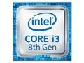

|  |
| --- |
| [Intel 酷睿i3 8100](https://union-click.jd.com/sem.php?unionId=281&siteid=20170818001&to=http://item.jd.com/5008447.html) |

-1+

￥949

* 主板*

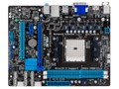

|  |
| --- |
| [华硕 A85XM-A](http://detail.zol.com.cn/motherboard/index350820.shtml) |

-1+

￥499

* 内存*

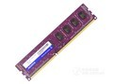

|  |
| --- |
| [威刚 万紫千红 4GB DDR3 1600](http://detail.zol.com.cn/memory/index325934.shtml) |

-1+

￥199

* 硬盘

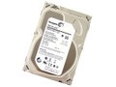

|  |
| --- |
| [希捷 Barracuda 3TB 7200转 64MB（ST3000DM001）](http://detail.zol.com.cn/hard_drives/index303421.shtml) |

-1+

￥585

* 固态硬盘

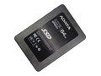

|  |
| --- |
| [威刚 SP600（64GB）](http://detail.zol.com.cn/solid_state_drive/index343071.shtml) |

-1+

￥269

* 显卡

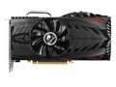

|  |
| --- |
| [七彩虹 630 雷暴鲨 D5 2048M](http://detail.zol.com.cn/vga/index329940.shtml) |

-1+

￥399

* 机箱

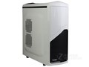

|  |
| --- |
| [航嘉 MVP标准版](http://detail.zol.com.cn/case/index381546.shtml) |

-1+

￥189

* 电源

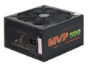

|  |
| --- |
| [航嘉 MVP500](http://detail.zol.com.cn/power/index360468.shtml) |

-1+

￥359

* 液晶显示器

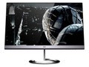

|  |
| --- |
| [HKC T3100](http://detail.zol.com.cn/lcd/index369191.shtml) |

-1+

￥730

* 键鼠套装

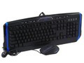

|  |
| --- |
| [精灵 雷神G116七彩背光游戏键鼠套装](http://detail.zol.com.cn/keyboards_mouse/index378431.shtml) |

-1+

￥150

* 音箱

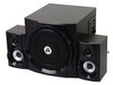

|  |
| --- |
| [金河田 S300](http://detail.zol.com.cn/speaker/index301329.shtml) |

-1+

￥218

* 光驱

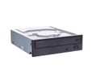

|  |
| --- |
| [先锋 DVD-232D](http://detail.zol.com.cn/dvdrw/index345264.shtml) |

-1+

￥89

合计 ￥4635

希望老师满意呀